PROJECT DOCUMENTATION
AI STUDY BUDDY API
TEAM ID: SWTID-2026-4270
TEAM LEADER: DEEPALAKSHMI.R – sivapeace2007@gmail.com
TEAM MEMBERS:
- DHANALAKSHMI.R – dhanalakshmikavitha205@gmail.com
- DHARSHINI.S – dharshudharshu18012007@gmail.com
- EZHIL.T – ezhil26204@gmail.com
- JANANI.G – jananigjanani545@gmail.com
PROJECT OVERVIEW:
The AI StudyBuddy backend follows a modular RESTful architecture designed to provide secure, scalable, and AI-powered learning services. The system processes client requests through Express.js, authenticates users using JWT, stores data in MongoDB, and communicates with the Google Gemini AI API to generate intelligent study resources.
The architecture separates authentication, business logic, AI services, and database operations into independent modules. This modular approach makes the system easier to maintain, debug, and extend while supporting features such as AI-generated summaries, flashcards, quizzes, and personalized study plans.
KEY OBJECTIVES:
he AI StudyBuddy backend provides intelligent learning assistance through secure and scalable REST APIs. The major features of the system are as follows:
- Secure User Authentication: Implements JWT-based authentication with encrypted passwords using bcrypt for secure user access.
- Study Material Management: Allows users to upload and manage study materials that serve as input for AI-powered learning features.
- AI Summary Generation: Generates concise and easy-to-understand summaries from uploaded study content using the Google Gemini API.
- AI Flashcard Generation: Automatically creates flashcards from study materials to improve concept revision and active recall.
- AI Quiz Generation: Produces multiple-choice quizzes based on uploaded content, enabling students to test their knowledge.
- AI Study Plan Generation: Generates personalized study plans according to the user's learning goals and available study time.
- Role-Based Access Control (RBAC): Provides different access privileges for Students and Administrators to ensure secure system management.
- MongoDB Data Storage: Efficiently stores user information, uploaded materials, and AI-generated learning resources using MongoDB.
TARGET USERS:
- Students – Study, revise, and generate AI learning resources.
- Administrators – Manage users and monitor the system.
SOFTWARE REQUIREMENTS:
- Operating System: Windows 10/11, macOS, or Linux (supports cross-platform operations).
- Node.js (v16 or above): Runtime ecosystem running server logic and routing infrastructure.
- npm (v8 or above): Node package manager to control operational dependencies.
- Express.js: Lightweight routing web framework to construct backend RESTful entry points.
- MongoDB: Document NoSQL engine storing users, posts, categories, comments, and analytics metrics.
- Postman: API verification toolkit to assert schema validation responses across administrative route shields.
- Code Editor: Visual Studio Code or similar IDE environment.
HARDWARE REQUIREMENTS:
- Processor: Intel Core i5 (8th Gen or above) / AMD Ryzen 5 or equivalent.
- RAM: 8 GB minimum (16 GB recommended for concurrent instances of MongoDB, processing layers, and execution nodes).
- Storage: 1 GB of available disk workspace.
PROJECT ARCHITECTURE

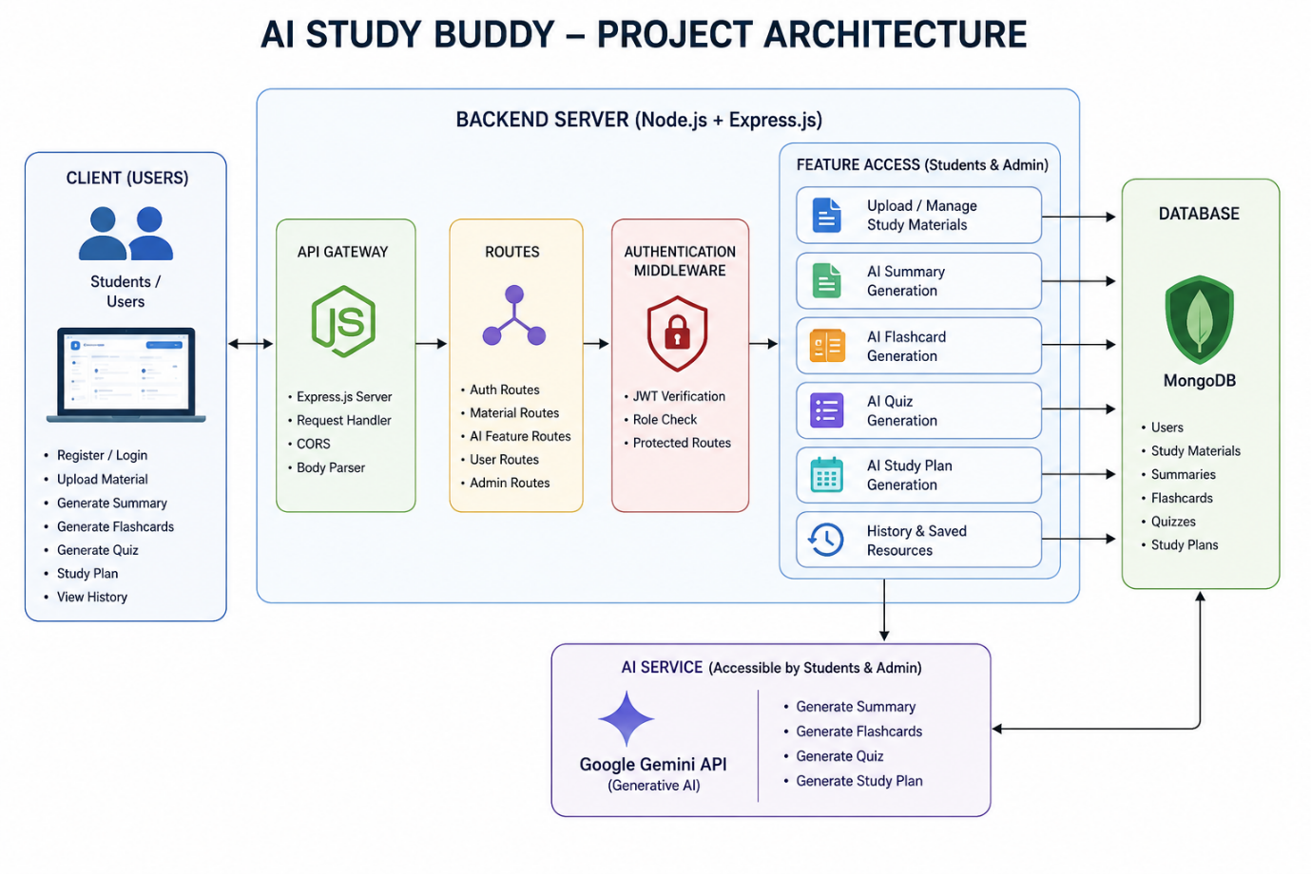
ENTITY-RELATIONSHIP (ER) DIAGRAM:

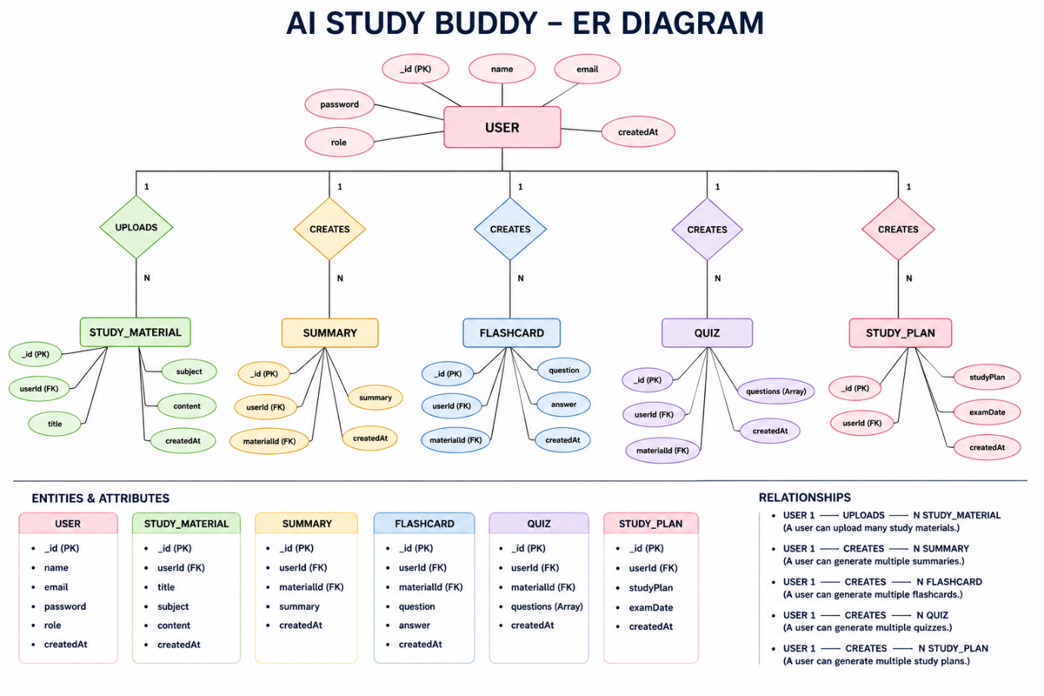
The AI StudyBuddy backend manages data through interconnected MongoDB collections that store user information, study materials, and AI-generated learning resources. Each entity is linked using logical relationships to ensure efficient data management and retrieval.
- User Entity
- Study Material Entity
- Summary Entity
- Flashcard Entity
- Quiz Entity
- Study Plan Entity
ROLES AND RESPONSIBILITIES:
Student
Students are the primary users of the system. They can register, log in securely, upload study materials, and utilize AI-powered features such as summary generation, flashcard creation, quiz generation, and personalized study plans. Students can also view and manage their previously generated learning resources.
Administrator
Administrators manage the overall system and ensure its smooth operation. They monitor registered users, manage user accounts, oversee application usage, maintain system integrity, and ensure that AI-powered services function correctly. Administrators also have permission to perform system-level management tasks and resolve user-related issues.
User Flow
The AI StudyBuddy application begins with the user registering or logging into the system. After successful JWT-based authentication, the user is redirected to the dashboard, where they can upload study materials and access AI-powered features. Based on the uploaded content, the system generates summaries, flashcards, quizzes, or personalized study plans using the Google Gemini API. All generated resources are displayed to the user and can be saved for future reference. Users can also manage their profile and view their previously generated learning resources through the dashboard.
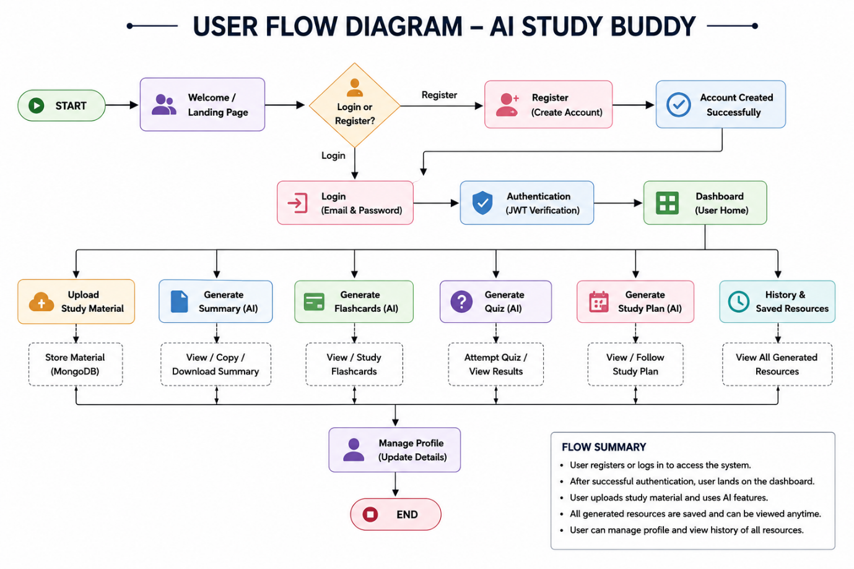

MVC ARCHITECTURE PATTERN:

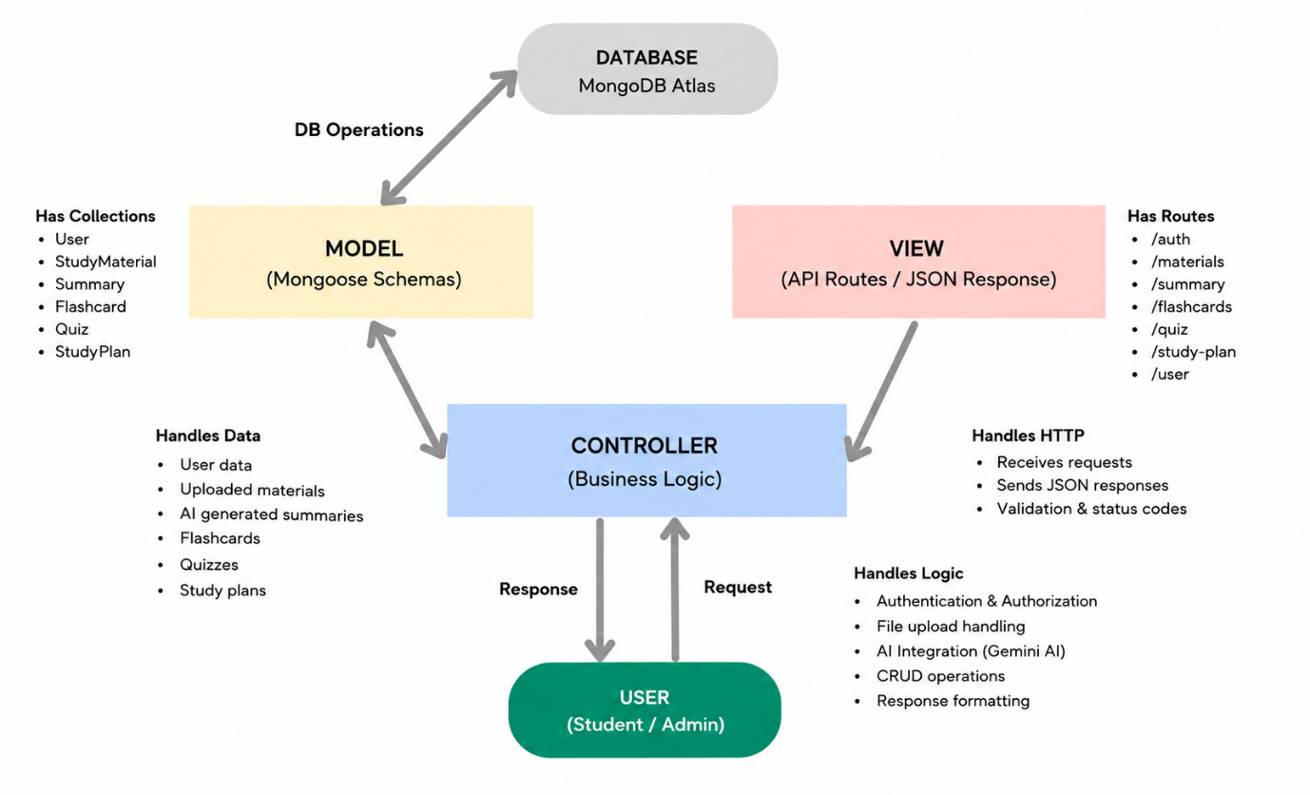
The AI StudyBuddy backend follows the Model-View-Controller (MVC) architecture to organize the application into separate layers, making the code modular, maintainable, and scalable.
PROJECT SETUP AND CONFIGURATION:
Creating the Project Folder
- Create a new folder named AI StudyBuddy .
- Open the project folder in Visual Studio Code.
- Initialize the project using Node.js and install the required dependencies.
Project Initialization
- Open the project folder in the VS Code terminal and execute:
npm init -y
- Install the required dependencies:
npm install express mongoose bcryptjs jsonwebtoken cors dotenv multer @google/genai
- Install Nodemon for development:
npm install --save-dev nodemon
Create the Following Files
- index.js
- .env
- package.json
- .gitignore
CREATE THE FOLLOWING FOLDER STRUCTURE:

ENVIRONMENT CONFIGURATION:
Create a .env file in the project root and configure the required environment variables.
PORT=5000
MONGO_URI=your_mongodb_connection_string
JWT_SECRET=your_jwt_secret
GEMINI_API_KEY=your_gemini_api_key
BACKEND DEVELOPMENT:
The AI StudyBuddy backend is developed using Node.js, Express.js, and MongoDB, following a modular architecture. The application separates routing, controllers, middleware, models, and utility modules to improve code maintainability and scalability. The backend exposes secure REST APIs for authentication, study material management, AI-powered content generation, and administrative operations.
Backend Structure
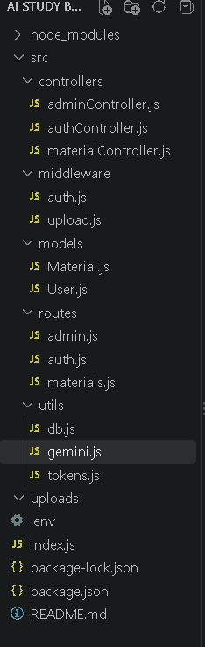

CORE SYSTEM SCRIPT IMPLEMENTATIONS:
1. Application Entry Point (index.js)
The index.js file serves as the main entry point of the application. It initializes the Express server, loads environment variables, configures middleware, establishes the MongoDB connection, registers API routes, and starts the server after a successful database connection.
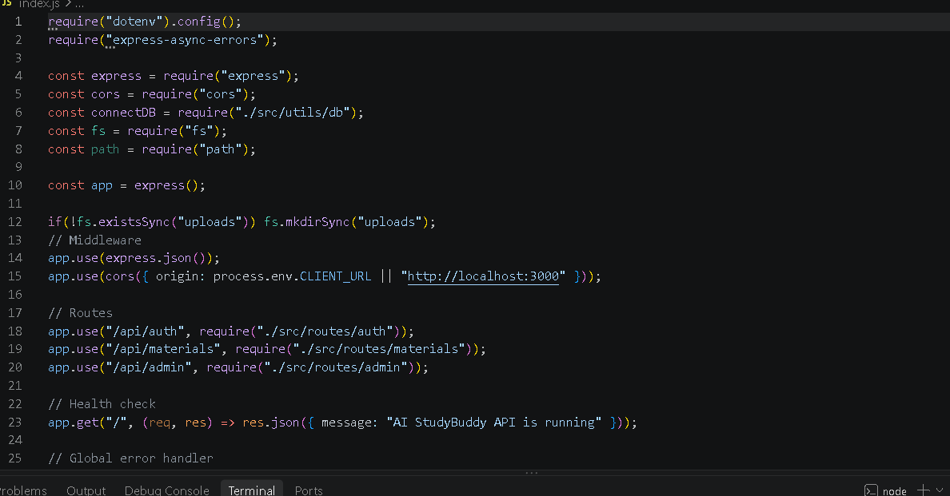
2. Database Connection (src/utils/db.js)
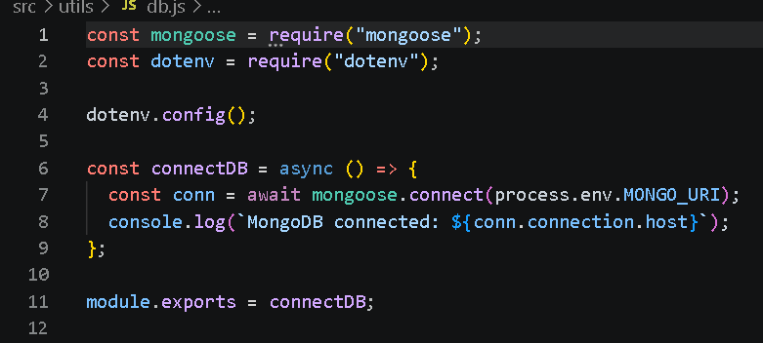
3. Authentication Middleware (src/middleware/auth.js)
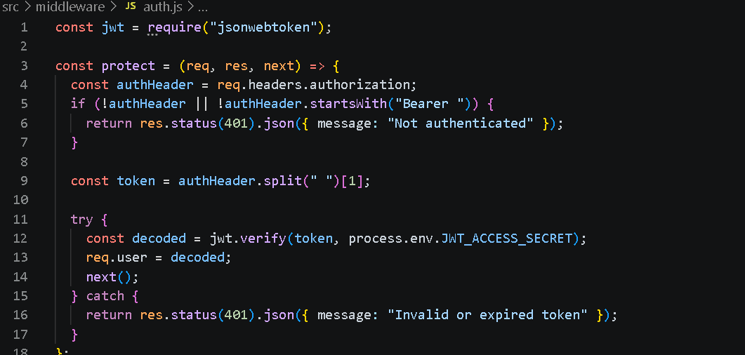
4. AI Integration (src/utils/gemini.js)
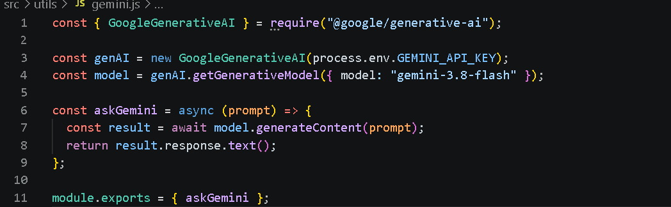
5. File Upload Middleware (src/middleware/upload.js)

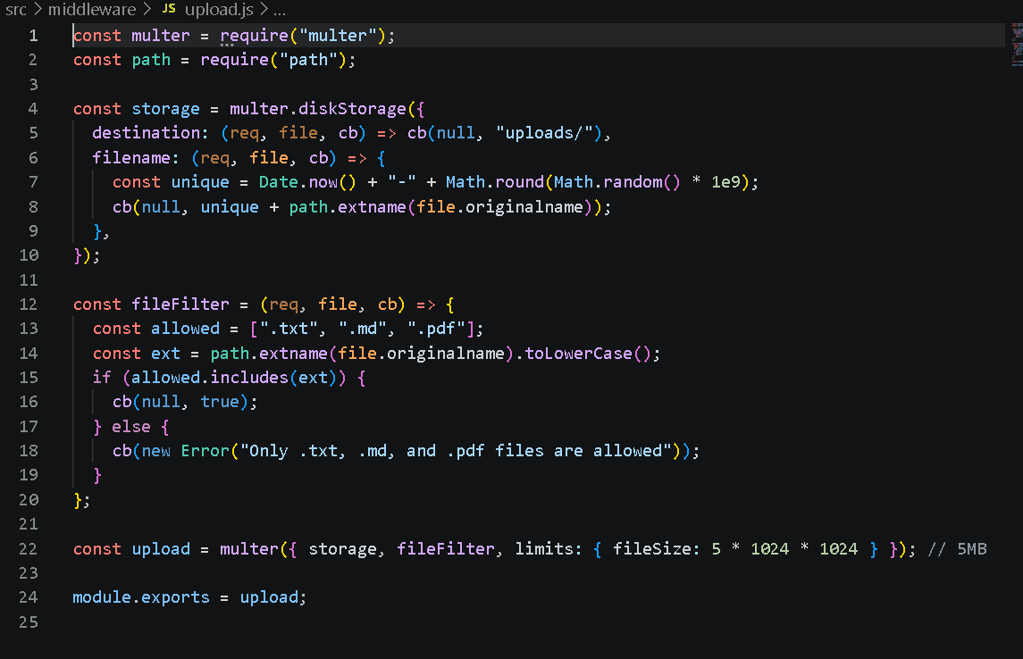
DATABASE CONFIGURATION:
Configure MongoDB
Install Mongoose using the following command:
npm install mongoose
CREATE DATABASE CONNECTION
Mongoose Schema Definitions
1. User Schema (models/User.js)

2. Study Material Schema (models/Material.js)

API ROUTE INTERFACE:
The backend exposes RESTful APIs to interact with the database and AI services.
1. Authentication APIs
2. Study Material APIs
3. AI Feature APIs
Provides endpoints for:
- AI Summary Generation
- AI Flashcard Generation
- AI Quiz Generation
- AI Study Plan Generation
4. Administrative APIs
PROJECT EXECUTION:
The AI StudyBuddy backend can be executed locally using Node.js. Before running the application, ensure that MongoDB is running and the required environment variables are configured correctly. The backend exposes REST APIs that can be tested using Postman or Thunder Client.
Running the Backend Server
Install all required dependencies:
npm install
Start the development server:
npm start
After successful execution, the server connects to MongoDB and starts listening for incoming API requests.
API TESTING:
The backend APIs can be tested using Postman.
1. User Registration
POST/api/auth/register
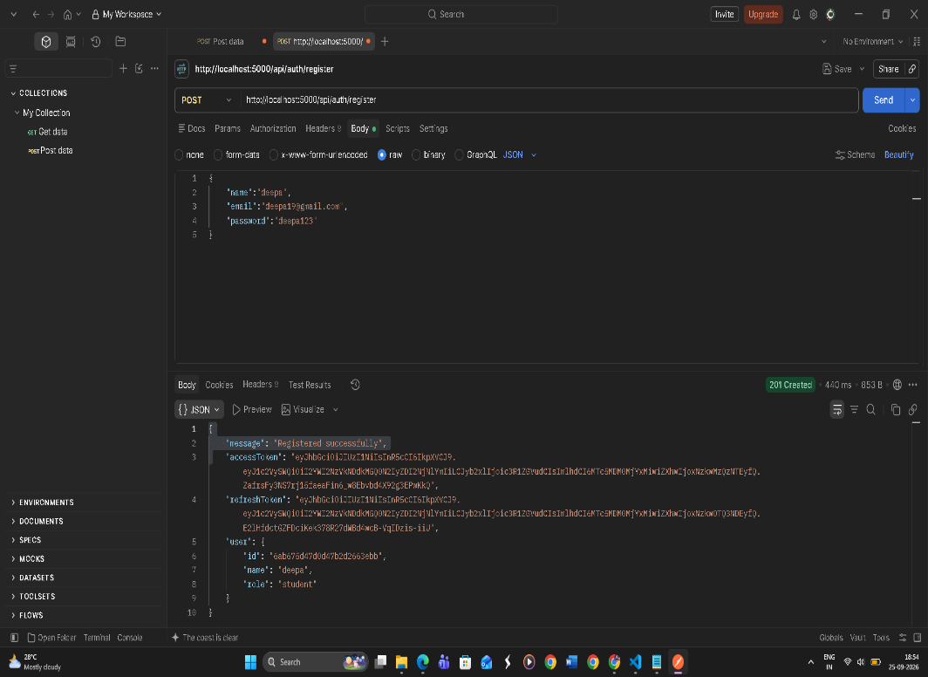
2. User Login
POST /api/auth/login
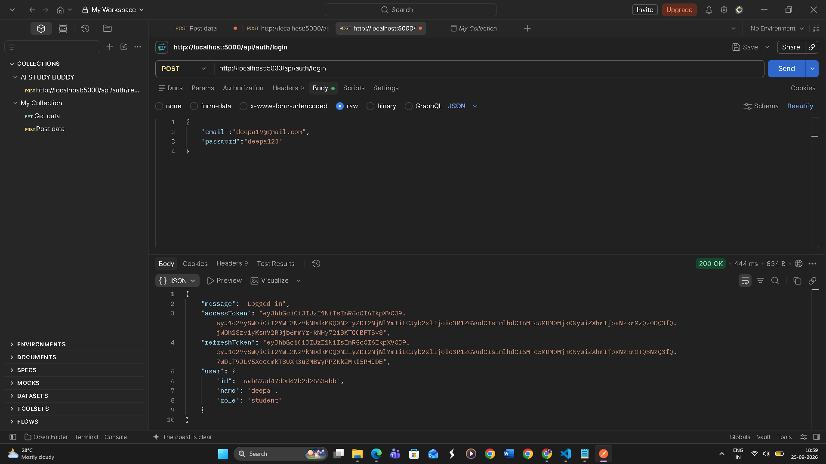
3. Upload Study Material
POST /api/material/upload
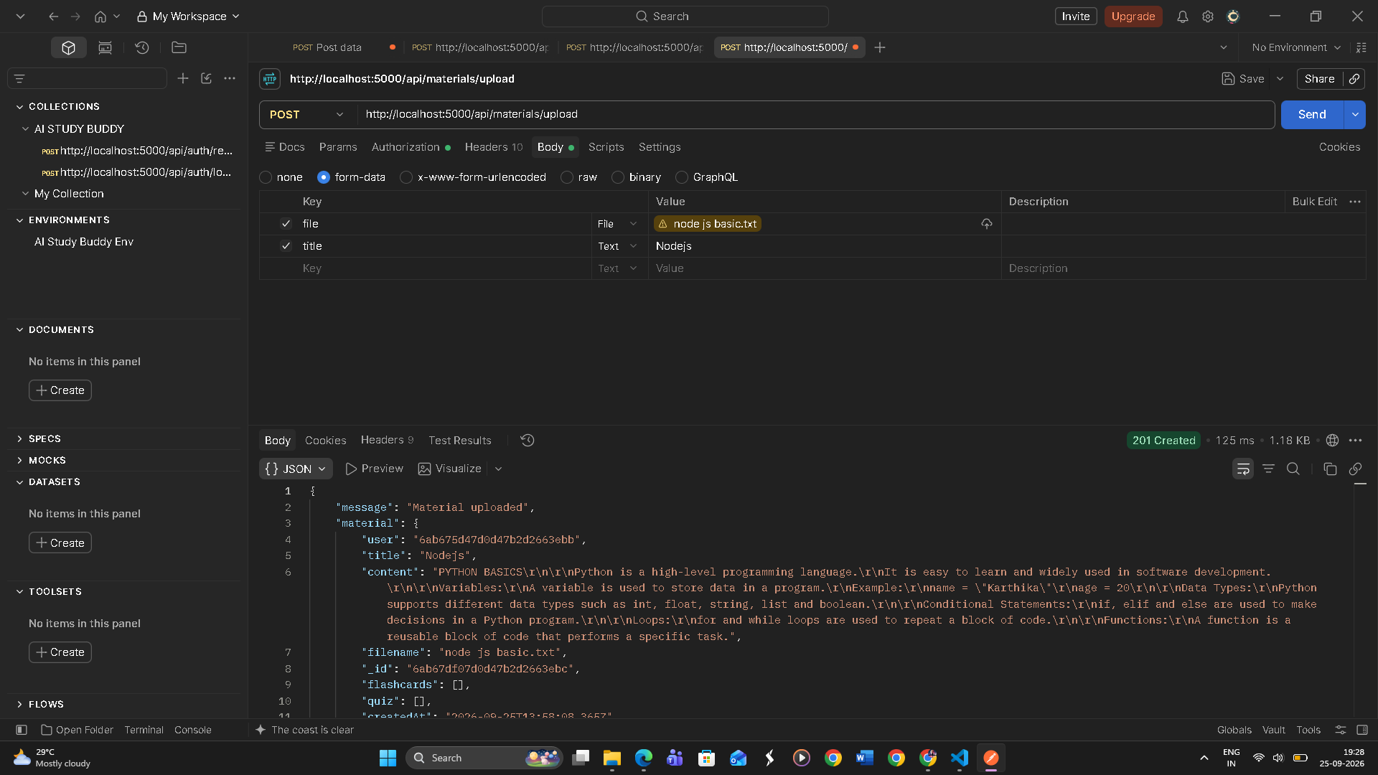
4. Generate AI Summary
POST /api/materials/:id/summarize
5. Generate AI Flashcards
POST /api/ai/flashcards
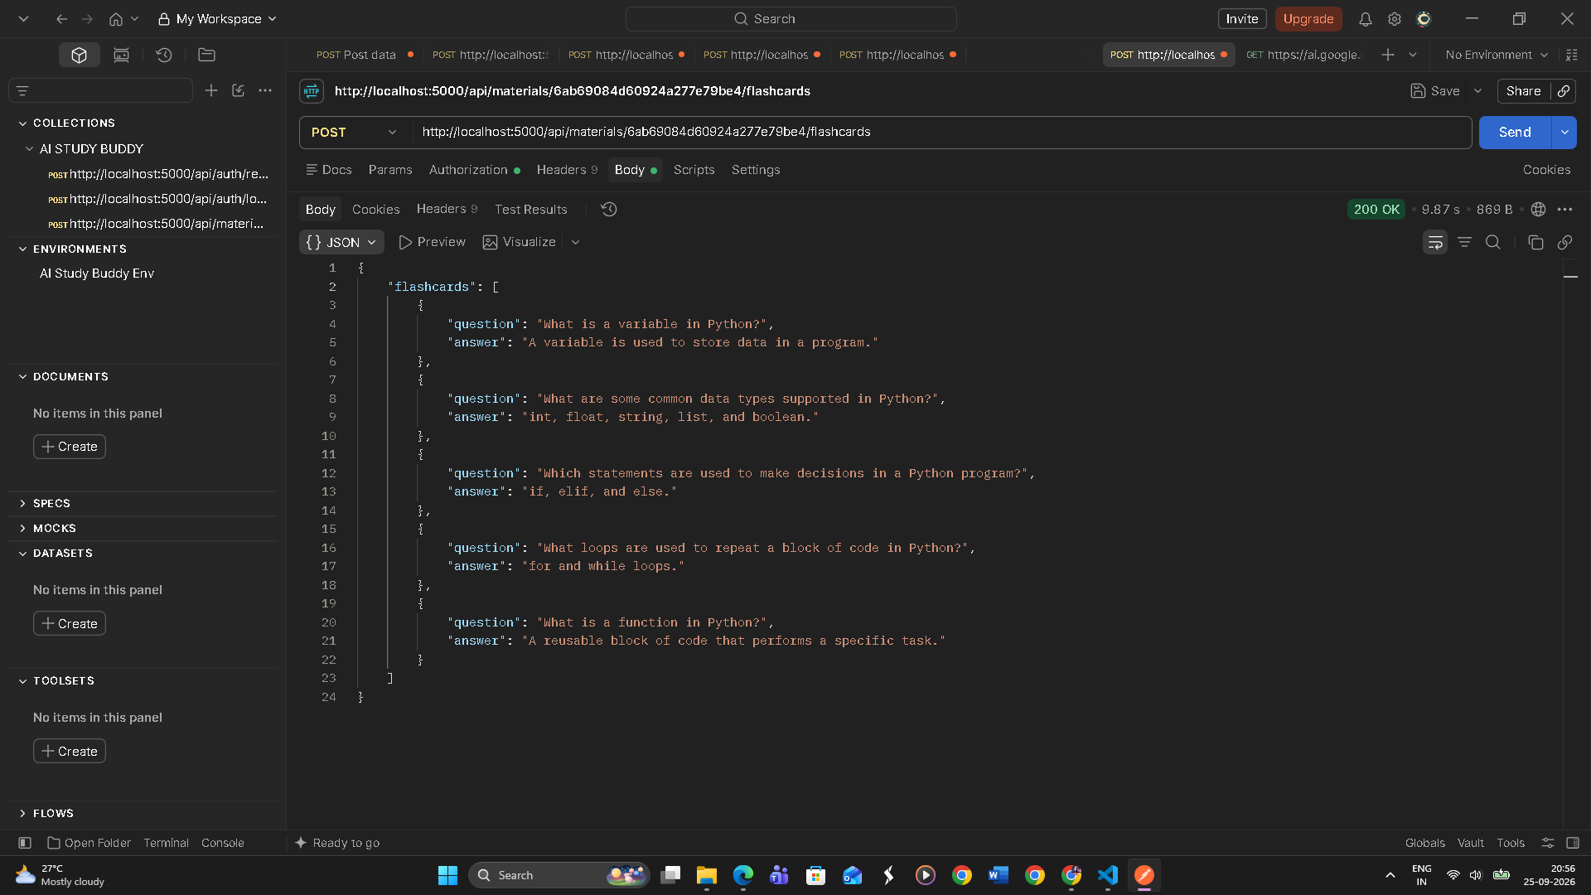
6. Generate AI Quiz
POST /api/ai/quiz
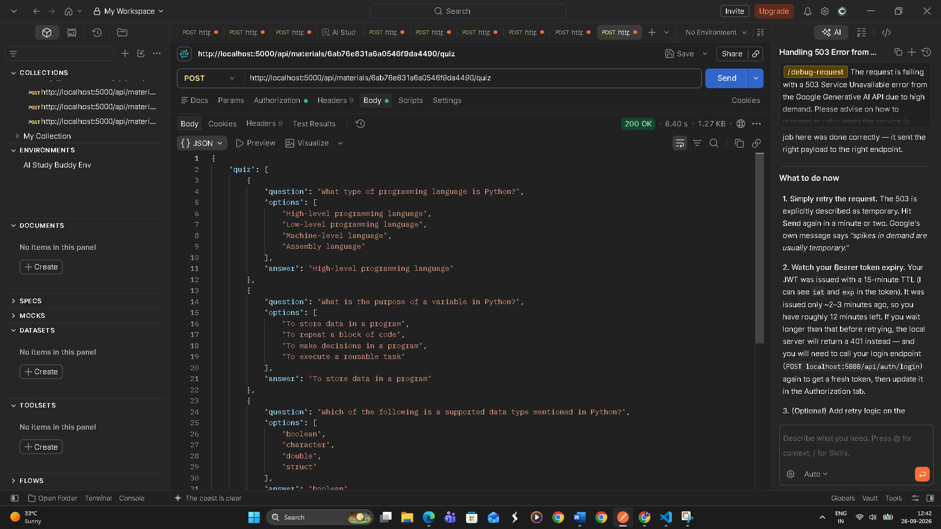
7. Generate AI Study Plan
POST /api/ai/study-plan
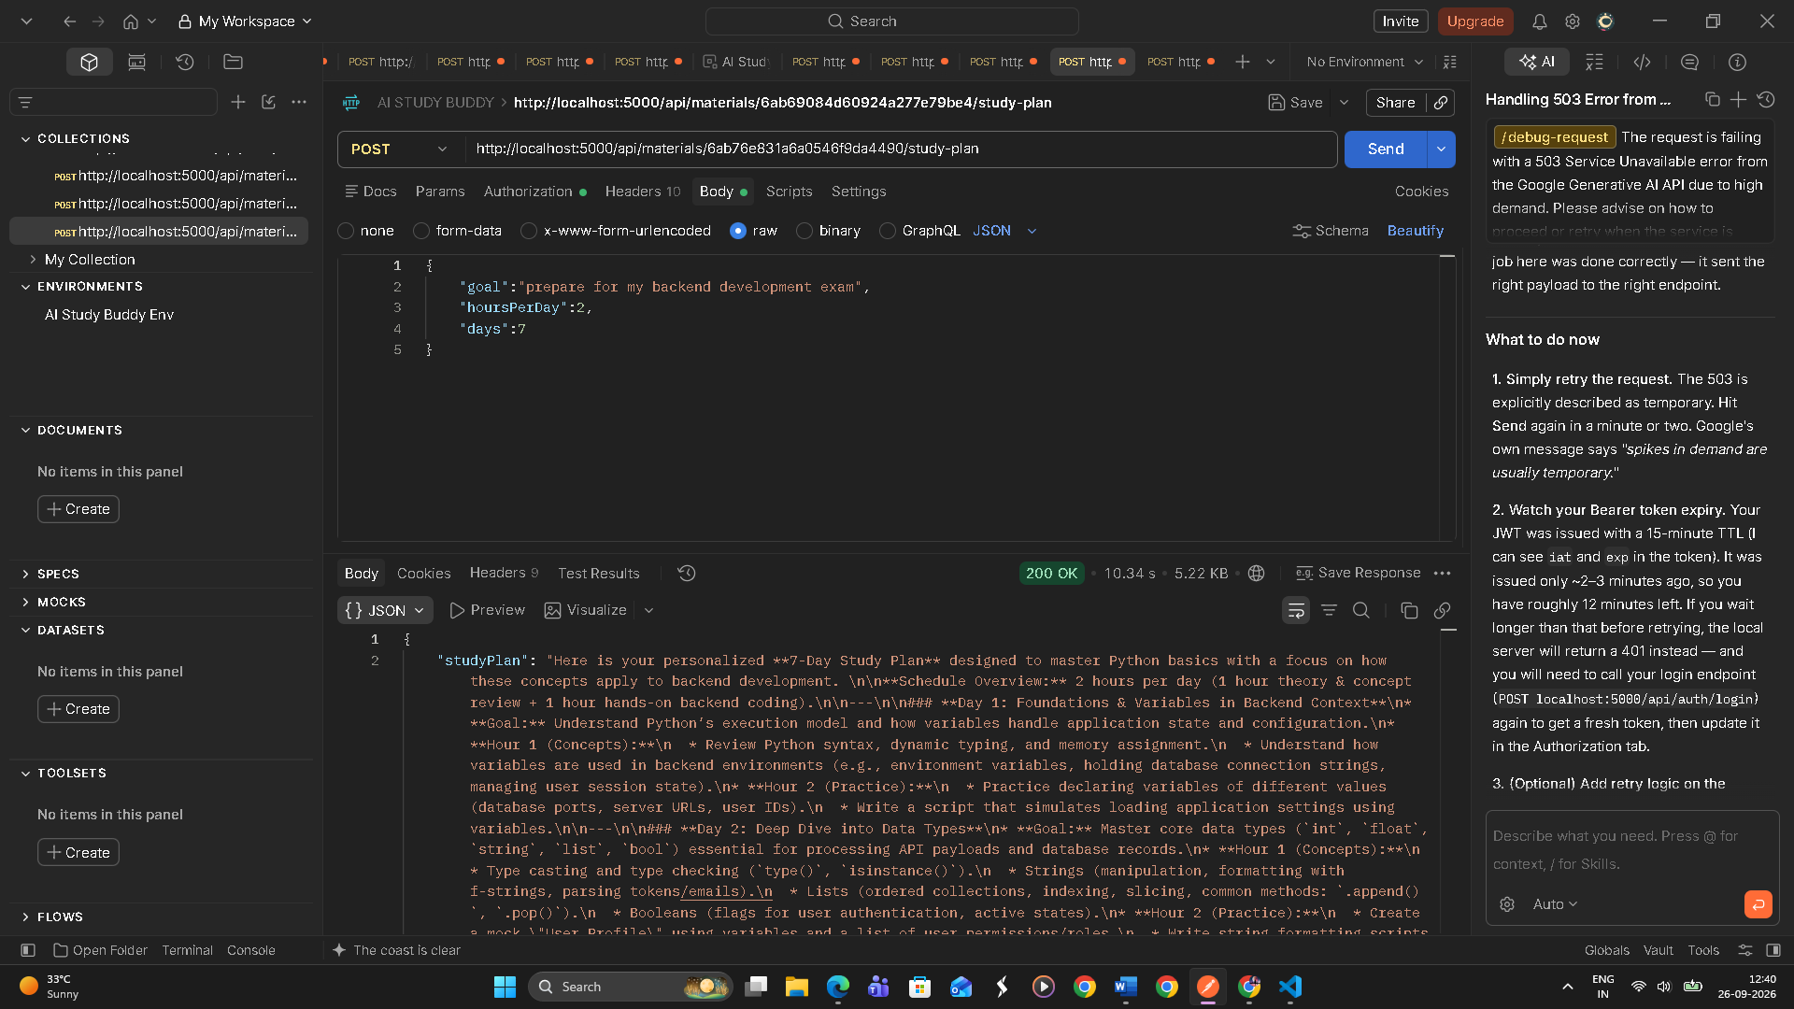
DEMO VIDEO LINK : https://drive.google.com/drive/folders/10z3TU8j8P9SdyD94b-9NGTiU-wDyRgBZ?usp=drive_link
CODE DRIVE LINK : https://drive.google.com/drive/folders/1yPQjRUzQlcVB0B2-a4qO-2XXMZg9MIG5?usp=drive_link

